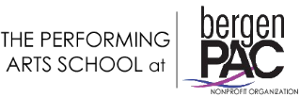

Scholarship Program Application 2022-2023

Date _____________________

Student’s Name _________________________________ Age ________

Parent’s name ___________________________________

Address _______________________ City ____________ Zip _________

Home Phone _________________ Cell Phone _______________________

E-Mail ________________________________________________________

Program Requested: ____________________________________________

Classes Requested _________________________________________

A limited amount of scholarships are available each year to those who meet the requirements. All information is confidential and brought before a bergenPAC committee.

The Performing Arts School @ bergenPAC is a non-profit organization.

