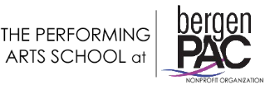

Scholarship Program Student/Parent Contract

Students who receive a Performing Arts School at bergenPAC Scholarship are held to a high standard of excellence and are expected to display a strong commitment both to the school and his/her career

*Scholarship Requirements:

- A strong financial need
- Exceptionally talented and/or wanting a career in the performing arts
- Exhibit a positive, professional attitude toward teachers, fellow students and staff
- Take the required classes
- Maintain a near perfect attendance

Please submit the following to apply:

- Completed Performing Arts School application form
- Completed Performing Arts School student/parent contract
- A letter detailing financial concern
- A copy of your latest tax form (1040) of student and/or guardian

I have read and understand the scholarship requirements for the 2022/2023 Performing Arts School academic year. I will abide by the school/theatre rules and policies to the best of my ability.

Student Signature _______________________ Date _____________

Parent Signature ________________________ Date _____________

